Arunachalam Iyer Family Honors
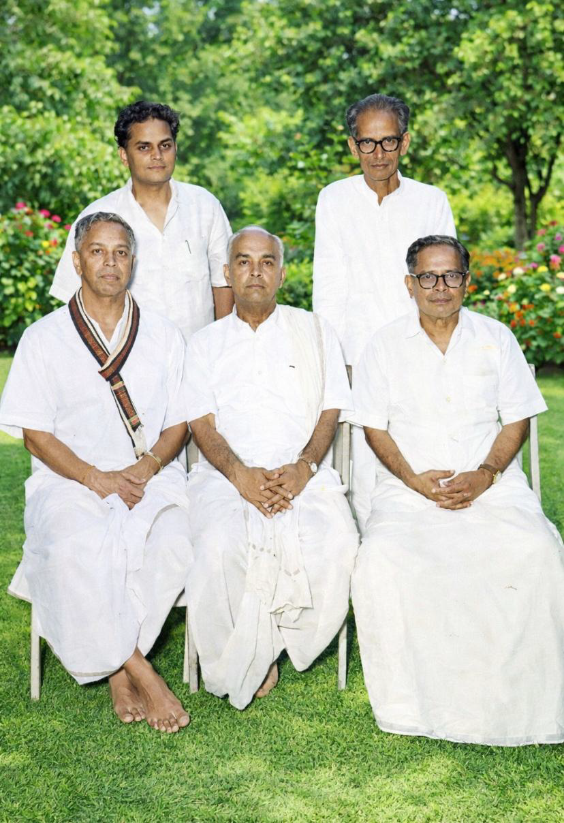
(Center -Mr A Sundaresan, Rigjlht side wearing angavastram Mr M Ganapathy ,
Left side Mr A Vaidyanathan, Behind Ganapathy Dr A Srinivasan
Behind Vaidyanathan Mr Ramaswamy )

- Mr Ganapathy Received Padma Bhushan Award in the year 1954

Mahadeva Iyer Ganapati (known as M. Ganapati) (1903–1976)^{[1][2]} was an Indian engineer who was well known for his accomplishments in national projects. The Rourkela Steel Plant in Orissa,^{[3]} and many Railway projects including Churchgate railway station in Mumbai and Chittaranjan Locomotive Works (CLW) were completed under his leadership. The Indian government awarded him the inaugural Padma Bhushan in 1954. He was the president of the Institution of Engineers (India) for 1973-74.

The main projects with which he was associated with are:
- Rourkela Steel Plant^{[5]}
- Kandla Port^{[6]}
- Malaviya Bridge at Varanasi^{[7][8]}
- Chittaranjan Loco Works^{[6]}
- Perambur Integral Coach factory^{[6]}
- Vivekananda Setu, Kolkata (as Deputy)
- Churchgate Railway Station and other Western Railway projects^{[9][10]}

Awards and Honors
- Railway Board Gold Medal, 1950
- Viceroy's Prize from Institution of Engineers India, 1953
- Padma Bhushan (1954)
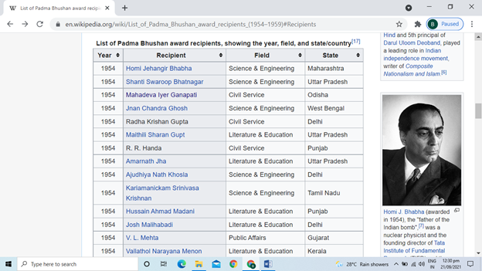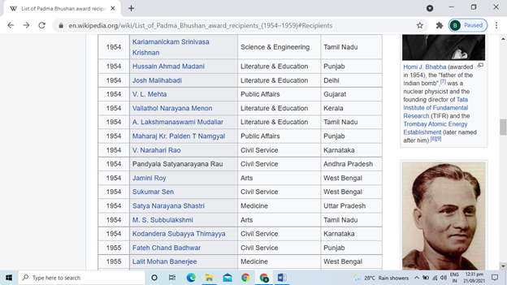

- Mr Arunachala Srinivasan Received Padma Bhushan Award in the year 1974

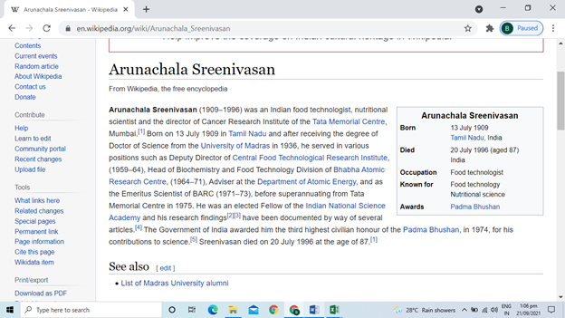

- Mr Arunachala Sundaresan

Mr Sundaresan was a genius in mathematics & known for his sharp memory.
Among his service period, he served as “Vadabathimangalam Estate Manager” at Thiruvarur.
Vadabathimangalam estate was one of the biggest in Thiruvarur owned by Mr Thyagaraja Mudaliar. Thyagaraja mudaliyar was a ardent devotee of Lord Thyagaraja swamy. Periodically he reviews his asset and its value with his manager & compares with asset value of Thaygaraja swamy temple. Whatever excess he finds will immediately transfer same to temple trust. His principle is his asset should never me more than that of temple.
To manage such estate he found Mr Arunachalam Sundaresan as an able person.

- Mr Vaidhyanathan Ganesan (grandson of Mr Arunachalam)

Mr Vaidyanathań´s son Mr Ganesan made super sacrifice and received peace time Mahavirchakra award in the year 1960.

